SmartCare v0.1 - Initial Engineering Brief and AI Activity Card
A2 Case Study Stage 1 student resource

SmartCare scenario
SmartCare Community Clinic currently uses spreadsheets and paper records to manage patients and appointments. The client says: 'We need software to help manage patients, practitioners and appointments.' This is not yet a complete specification.

Initial Engineering Brief

Problem summary
Currently SmartCare Community Clinic relies on fragmented manual processes such as spreadsheets and paper records to manage patient information and appointments. This has resulted in major operational inefficiencies including double bookings, trouble finding patient histories and non-uniform appointment statuses. Without a centralised system, it is also difficult to track practitioner availability and generate basic operational reports. Management needs a simple, manageable software solution to replace these manual processes and make patient, practitioner and appointment management easier without the implementation of complex hospital-wide system.

2. Initial stakeholders
Stakeholder | Possible need
Clinic Management | Precise operational reports, less administrative work and a trustworthy overview of clinic activity.
General Practitioners (GPs) | Better visibility of their day-to-day schedules, easy access to patient records, and fewer scheduling conflicts.
Patients | A reliable booking process, No double appointments. Confidence in their records being correct.
Reception/Admin Staff | A efficient booking system, quick patient lookup, easy cancellation processes, and a single source of truth for appointments.

3. Initial features
Feature | Confirmed or provisional? | Why?
Patient Registration | Provisional | The client mentioned managing patients, but specific data fields such as DOB and address are not yet defined.
Appointment Booking | Confirmed | Explicitly requested by the client to solve duplicate bookings.
Practitioner Management | Confirmed | Explicitly requested by the client to manage practitioner availability.
Appointment Cancellation | Confirmed | Identified as a manual process problem in the case study.
Operational Reporting | Provisional | Mentioned as a difficulty but specific report types such as daily and weekly are unknown.
Patient Record Search | Provisional | Implied by “difficulty location patient records,” but search criteria such as name, ID and phone are unknown.
Appointment History | Provisional | Mentioned as a “lack of reliable appointment history,” but how far back it should go is unknown.

4. Questions for the client
1. What particular information (fields) should be stored for a patient and a practitioner?
2. How would you like to define “practitioner availability” (shifts, particular hours, lunch breaks, etc.)?
3. Are there specific rules for patient to cancel or reschedule an appointment (e.g., a week before)?
4. What particular reports should be generated (daily schedule, practitioner workload, number of absent appointments, etc.)?
5. Who will use the system (will patients schedule their own appointments, or will receptionists do that for them)?

5. What we do not yet know
1. The specific technical constraints (e.g., must it be a web application, a desktop application, or a mobile application? Does it need to be compatible with multiple devices?).
2. The specific business rules for appointment durations and buffer times between patients (e.g., are all appointments 15 minutes, or do they vary depending on the practitioner?).

AI Activity Card - Ask, Check, Explain

Before AI
There is yet no code at this point, this is my Initial Engineering Brief. I have created a summary of possible problems of the clinic and it’s stakeholders and features that need to be supported.
Problems that I can see in my own brief at this point include:
- I have made numerous assumptions about the clinic’s current operations, such as who does the booking, (receptionists vs, patients).
- I have not provided any definitions for “practitioner availability” in terms of data (shifts, working, hours, days off).
- Several features are marked as “provisional” while I have not defined the necessary data fields for them.
- “Operational reporting” seems too vague as it is unclear what “basic reports” entails.
- I have not specified the length of each appointment, nor have I included tentative time intervals between patients.

AI request

AI Response:

Your initial brief is a solid start. You have correctly identified the core problems: manual processes, duplicate bookings, and lack of reporting. However, I can see a few potential gaps:

1. Scope Creep Risk: You listed "Operational Reporting" as provisional. If management wants complex reports, this could balloon the scope beyond a "simple" system. Have you asked them what "basic" means?

2. User Roles: You listed both "Reception/Admin Staff" and "Patients" as stakeholders. If patients are not direct users, their "need" is really a need of the clinic to serve them better. Does the system need a patient portal, or is it purely internal?

3. Data Integrity: You mentioned preventing duplicate bookings. What happens if two receptionists try to book the same slot at the exact same moment? This is a concurrency issue that may affect your non-functional requirements.

4. Feature Ambiguity: "Appointment History" is listed as provisional but no time range is specified. Should history go back one month? One year? Five years?

Questions for you to consider:

- What is the minimum data required to uniquely identify a patient (Name + DOB, or a unique ID)?

- If a practitioner is sick, how does the system handle cancelling all their appointments for that day?

- Does the system need to handle multiple appointment types (standard consult, long consult, vaccination)?

Evaluate
Suggestion | Useful | Unclear | Incorrect | Out of scope
Ask what “basic” reports means | Yes
Clarify if patients are direct users | Yes
Consider concurrency for double-booking | Yes
Ask about handling practitioner sickness |  | Yes
Ask about multiple appointment types |  |  |  | Yes

Decide
For each significant suggestion: Accept / Modify / Reject / Keep unverified.
- “Ask what basic reports means” → Accept. I will add a question to the client about what specific reports they need.
- “Clarify if patients are direct users” → Accept. I will clarify in my assumptions that the system is for internal clinic use only (receptionists and GPs).
- “Consider concurrency for double-booking” → Modify. I will note concurrency as a technical risk in the “What we do not yet know” section, rather than a functional requirement for now.
- “Ask about handling practitioner sickness” → Keep unverified. Good edge case but may be out of scope for the first version. Kept as an open question.
- “Ask about multiple appointment types” → Reject. The case study does not mention different appointment types. Out of scope for v0.1.

Verify
- Run the code: N/A there is no code yet in Stage 1.
- Test normal input: N/A
- Test unusual input: N/A
- Compare with requirements: After reading the case study. It explicitly. Says “The organization does not want a complex hospital information system.” My brief aligns with this by keeping scope small.
- Ask tutor/peer: I will ask my tutor if the Initial Engineering Bried needs technical constraints or just business needs.
- Check documentation: I checked the assignment brief and Stage 1 template to ensure all required sections are filled in.

Explain
Yes, I can explain my brief. The AI’s feedback helped me realise I need to explicitly state that this is an internal tool for staff, not a patient-facing portal.
I still need to understand:
- The specific data fields required for a patient record.
- The exact rules for practitioner availability.
- What “basic reports” actually means to management.
These will be addressed through the client questions I listed in Section 4.

Lab/Python Activity – Evidence
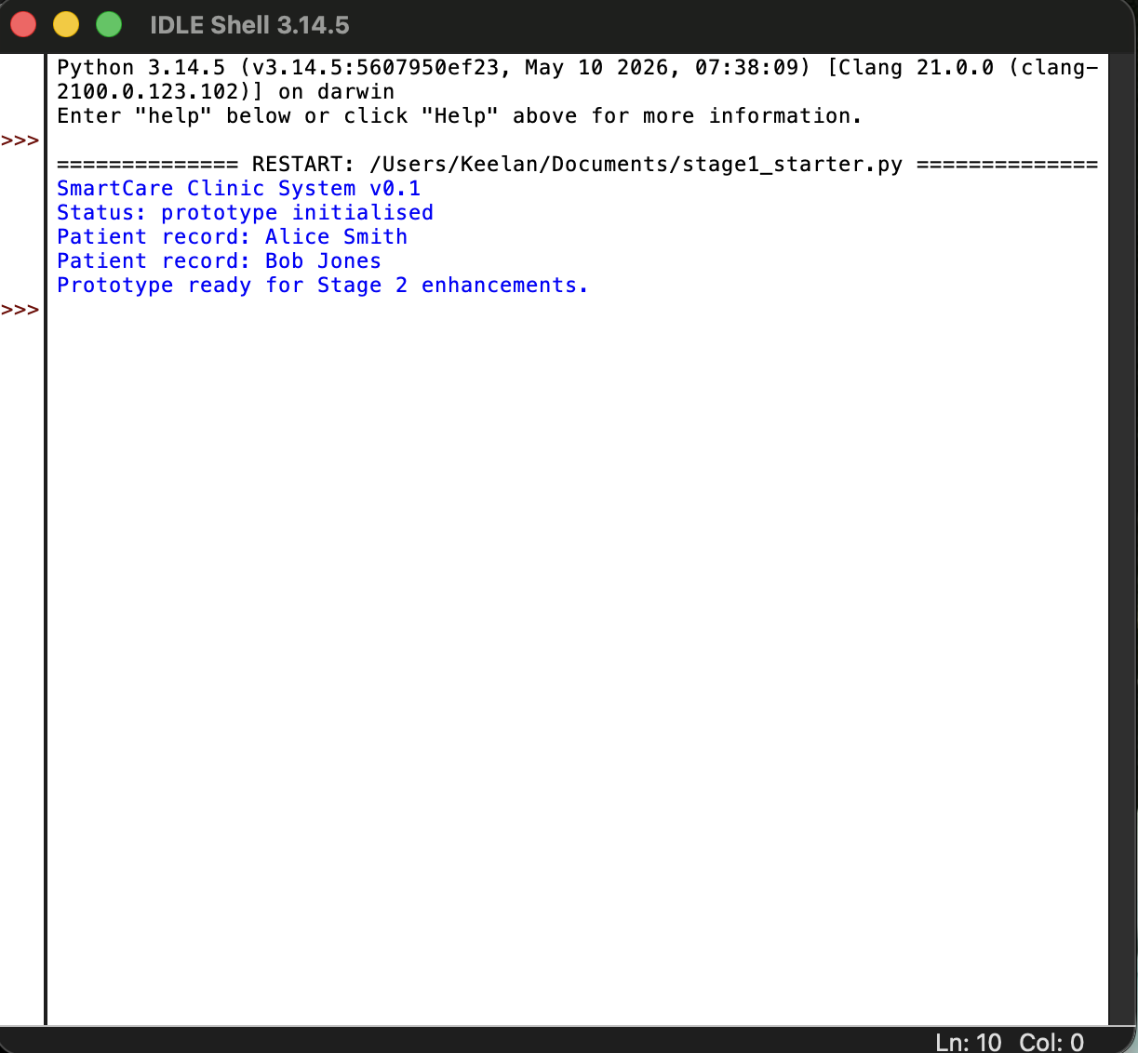
Stage 1 starter prototype executed successfully via stage1_starter.py using Python 3.

